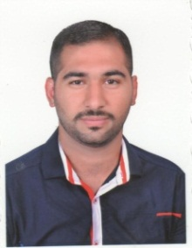***Personal Details:***

***Name*** **Bashar Abdulsattar Abdullah**

***Date of Birth*** may 27th 1989

***Place of Birth*** Baghdad, Iraq

***Nationality*** Iraqi

***Gender*** Male

***Marital Status*** married

***Contact Information:***

***Home Address*** H. 4, Str. 21, Dist. 632, Hay AL Ameriya, Mobile: +964 771 320 2987

, Baghdad, Iraq

**E-mail:**[**basharabdulstar@gmail.com**](mailto:basharabdulstar@gmail.com)

[**basharabdulstar3@yahoo.com**](mailto:basharabdulstar3@yahoo.com)

**Experience: -**

**\*(March 2015 – Till now)**

**Field Energy and Oil Services Company.**

* Work as Sales Engineer for **G.E. Oil and Gas DTS / Nuovo Pignone**, Centrifugal Pumps, Gas and Steam Turbines and Compressors, through their distributor **FIELD ENERGY AND OIL SERVICES LTD,**
* Work as Sales Engineer **ITT-BORNEMANN** screw pumps through their distributor **FIELD ENERGY AND OIL SERVICES LTD**.
* Projects:
* Supply Spare parts FOR Novo Pignone PUMPS to Midland refineries company.
* Supply Compressors and vacuum pumps Novo Pignone to Midland refineries company.
* Supply complete assembled inter stage Gas cooler for centrifugal compressor Item 1051J3C to South refineries company Novo Pignone project No. ( 5237/B)
* Conduct site survey in **South refineries company** on all GE Nuovo Pignone Pumps.
* Conduct site survey on **G.E** equipment in all oil pipelines company sites in Iraq.
* Conduct site survey on **G.E** equipment in oil depots for south oil company
* Supply Spare parts for Nuovo Pignone injection pumps to **3J Engineering Solutions DMCC end user Exxon Mobil Services Iraq.**

**\*(June 2012 –till March 2015)**

**Al-Usool engineering services company LTD.**

* Work as Sales and application Engineer for **ITT-Gould`s** CentrifugalPumps through their distributor AL Usool company.
* Work as Sales Engineer for **LEWA** Dosing pumps through their distributor AL Usool company.
* Work as Sales Engineer for **Albany** Gear & screw pumps through their distributor AL Usool company.
* Work as Sales Engineer for **Viking** /Gear pumps through their distributor AL Usool company.
* Worked as Sales Engineer for **John crane** / Mechanical seals and coupling through their distributor AL Usool company.

**Training:**

**\* October 2012** Training on **(E-prism) Pumps selection program** and **pumps** **hydraulics** by ITT-Gould`s Pumps in Istanbul /Turkey.

* **October 2013** Training course for OTM s.r.l. on **Drainage Pumps** in Massa / Italy.

* **April 2015** G.E Oil & Gas product orientation for Nuovo Pignone Pumps and Compressors and G.E turbines for downstream technology solution, Abu Dhabi.

\***November 2016 GE Oil & Gas MENAT TMS-DTS Channel Partner Training**

**\*Online Courses: -**

* API 618 Reciprocating Compressors 1 - API 618 Reciprocating Compressors Familiarization
* EHS 1 - Downstream Technology Solutions Environmental, Health and Safety Overview
* Pumps 1 - Centrifugal Pumps Familiarization
* Reciprocating Compressors 1 - 1. AJAX Product Overview
* Systems 1 - Gas Systems Familiarization
* Valves 1 - Valve Familiarization
* L101 Machine Criticality
* Marketing 1 - Downstream Technology Solutions Overview
* Channel Compliance Learning Series

**Skills: -**

* 6 years’ experience in oil and Gas Industry.
* Operation System: Windows, Linux,
* General Tools: Microsoft Office, (Excel, Word, Outlook,) PDF creator and editor,
* Design and simulation Tools: MATLAB, AutoCAD, ANSYS.
* Professional in hardware, software and IT& networking maintenance and troubleshooting

***Academic*** ***Qualifications:***

***Nahrain University, Baghdad, Iraq. Sep. 2008-Jun. 2012***

B.Sc. in Mechanical Engineering

Final Year Project Title: *six-legged kinematics moving machine*

Supervisor: Asst. Lect. Ammar Essam

Average mark: 75.20%

Main Study Subjects: Statics, Dynamics, Mechanics of Material, Fluid Mechanics, Thermodynamics, Mechanics of Machines, Mechanical Construction, Machine Design, Power Plant, Automatic Control, measurements, Gas Dynamics, Vibration, Heat Transfer, Air Conditioning and Refrigeration, internal combustion engines, manufacturing process, Language of the Study: English

***Summer Training Courses:***

***\*(Jul. 2011-Aug. 2011)***

**Schlumberger: Oilfield Services, Coiled Tubing Service north Rumaila Basra, Iraq**

Intensive theoretical course with practical application for 12 hours daily of equipment’s and machinery of coiled tubing service technique, especially with the following equipment’s: -

-**MPF 331** (multi-purpose pumping float unit) and its components,

- **VX** equipment’s & components: Venturi measurement.

- **Separator:**

- **Control valves, Safety devices**

- **BOP** (Blow Out preventer).

***\* (Jun. 2011-Jul. 2011)***

***Ministry of water resources, Al Saedya Baghdad,*** ***Iraq.***

Intensive course at Workshops in vehicles and cars and generators and diesel engine repair and maintenance

***Memberships:***

***Iraqi Engineers Union, Iraq. (Jun. 2012 – Present)***

Title: Assistant Engineer

***Languages:***

* Arabic Native
* English Fluent

**- References:**

- Essam Alaa Abdulamajeed -Sales Manager **at Field Energy and Oil Services company** Tel: 00964 7809166632

- Vishwajit Kasture Technical Sales Leader **Baker Hughes a GE company/ Nuovo Pignone S.p.A**. Pump, Valves and Systems

M +971 52 8007175

- Alaa T. Jasim Service and sales manager-Iraq at **John Crane Middle East FZE** (Mechanical seals):-

Tel: 00964 7704445189

- Mustafa Tariq Division manager **in Al-Usool Engineering Company**

Tel: 00964-7809166631

Marwan +9647903442622 Chemical engineer / **Schlumberger**  
Ismael M. Mahdi Mechanical Field Engineer +964-7821583150 / **Schlumberger**

**Certifications:-**

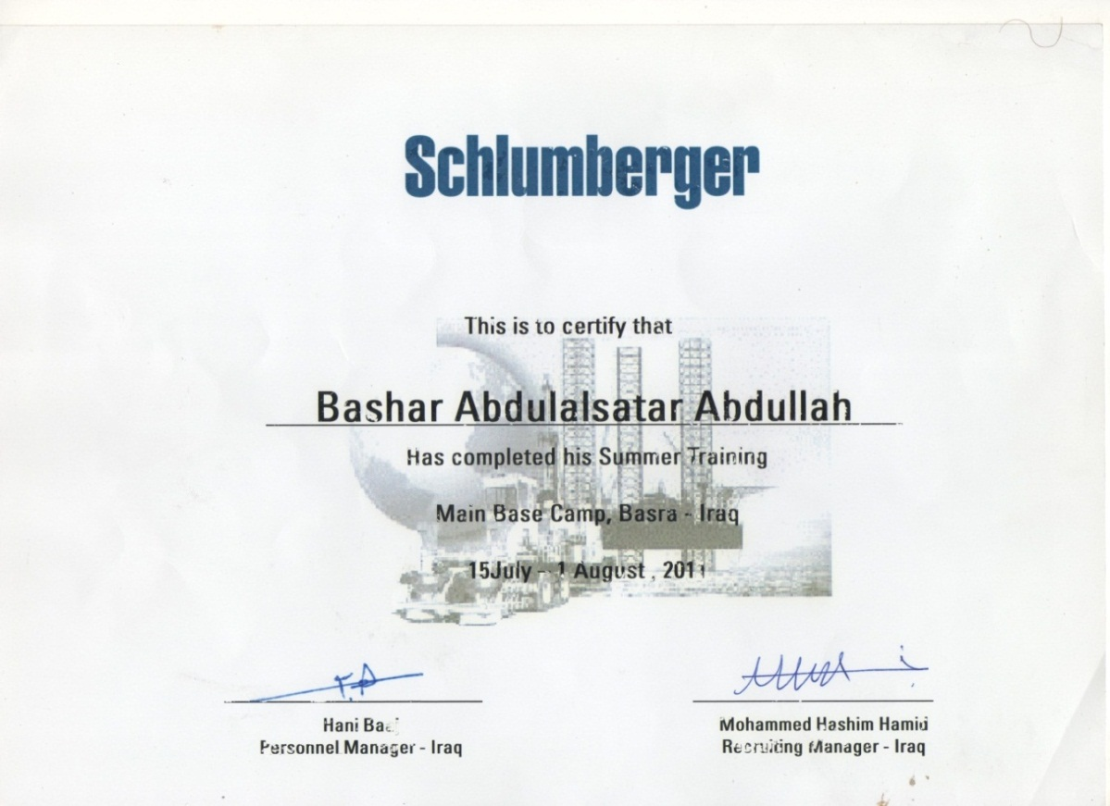

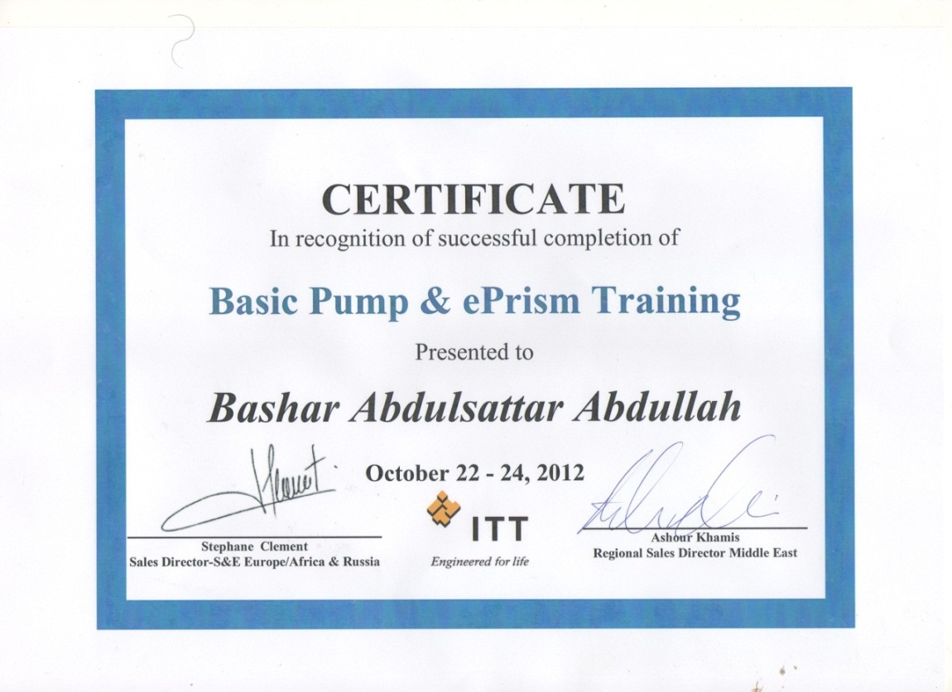

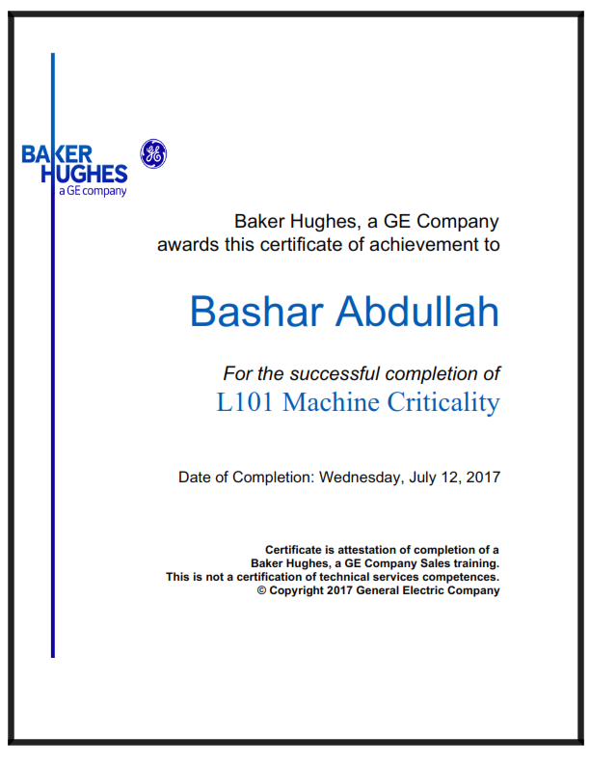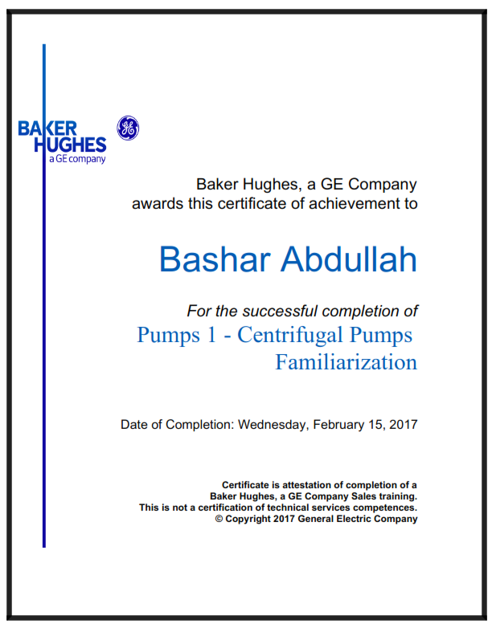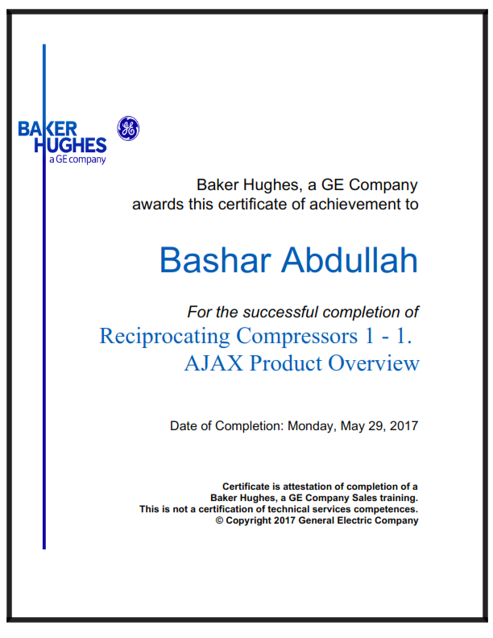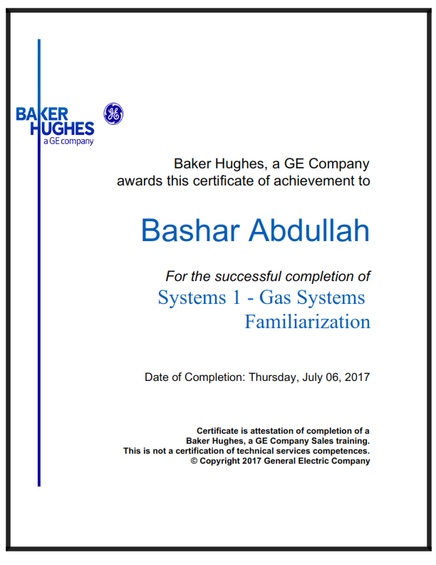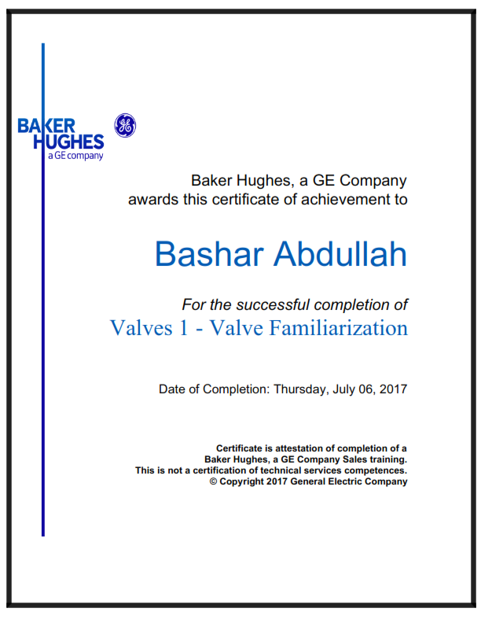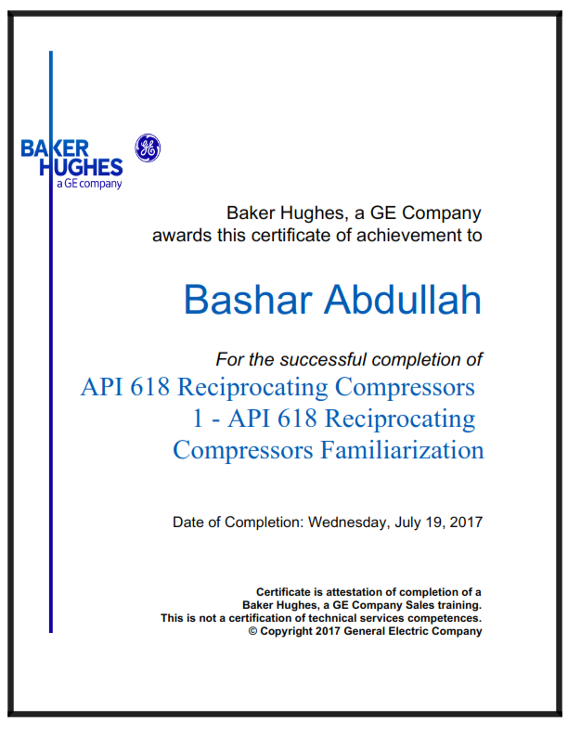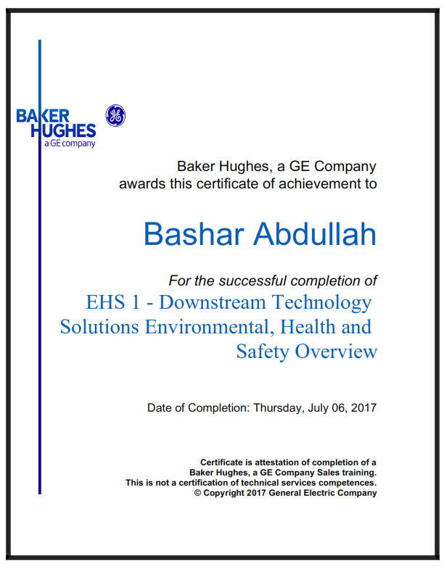

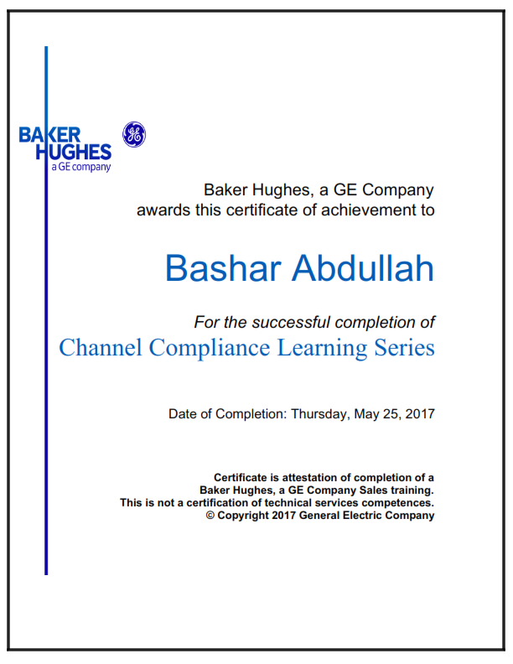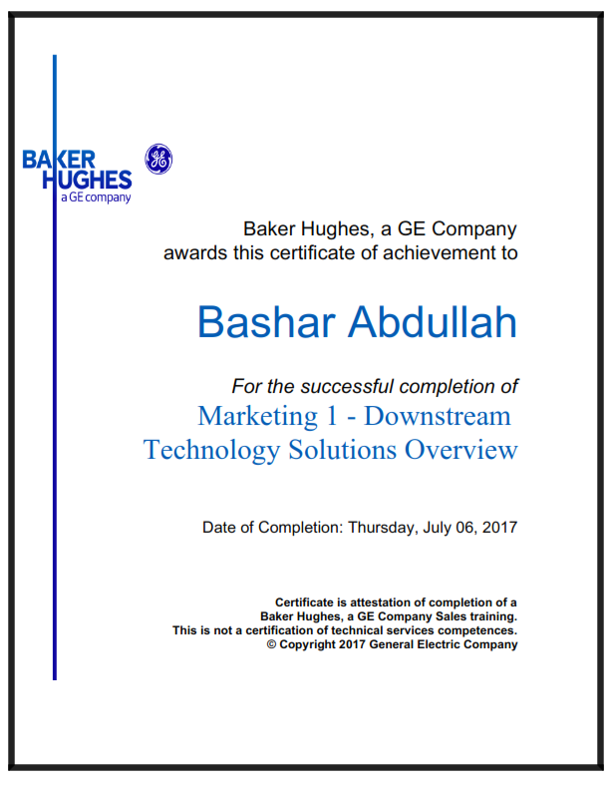

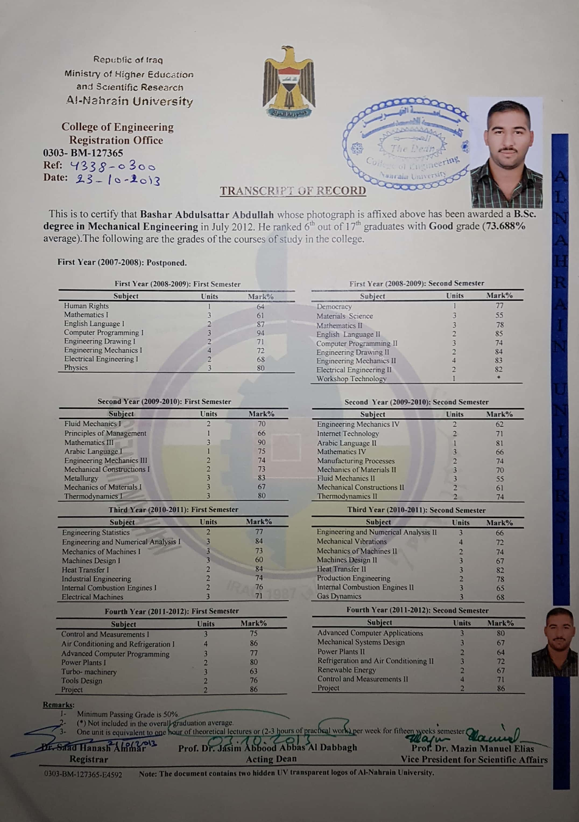

I declare that all the contents of my Curriculum Vitae are correct and I pledge to provide all certified documents and references upon request.

(*Last update: February, 2018*)